TEMA: CONDICIONES Y PREDICCIONES: Oraciones condicionales. Condicionales probables, improbables e imposibles. Nexos de oraciones y de párrafos.

Nivel gramatical: Modo subjuntivo: Oraciones condicionales. Predicciones.
MODO INDICATIVO MODO IMPERATIVO MODO SUBJUNTIVO
Expresa la significación del Expresa ordenes, pedidos, Expresa un deseo, propuesta o
verbo como real sugerencias suposición nunca una realidad

The computer calculates the Don’t buy a dot matrix If you don’t save your document you
total cost will lose the information.

Las oraciones condicionales, normalmente con el verbo en modo subjuntivo expresan predicciones. Predicción es una aclaración acerca de un tema en particular en el cual nosotros decimos lo que pensamos va a pasar en el futuro. No son siempre absolutas pero podemos expresar diferentes niveles de certeza, de acuerdo al contexto en el cual fueron hechas.
Las oraciones se forman por dos clausulas: la cláusula “if” y la cláusula principal
Los diferentes grados de certeza pueden expresarse de las siguientes formas o tipos:

- TIPO CERO: Zero Type (100% Certeza) - Hechos generales

If /Unless clause  Present Tense (Simple, continuous or perfect) | Main Clause  Present (simple present)

If you heat ice | it melts.

- PRIMER TIPO: First Type (probables o posibles) - Una condición posible y su resultado probable

If /Unless clause  Present Tense (Simple, continuous or perfect) | Main Clause  Future (Simple, Perfect, Modal, Imperative)

If you don't hurry | you will miss the train.

- SEGUNDO TIPO: Second Type (Improbables) - Una condición hipotética y su resultado probable

If /Unless clause  Past Tense (Simple Past) | Main Clause  Conditional (would + verb infinitive)

If this thing happened | that thing would happen.

- TERCER TIPO: Third Type (Impossible) -

If /Unless clause  Past Perfect Tense | Main Clause  Conditional Perfect (would have + verb infinitive)

If you had studied harder | you would have passed the exam.

Las oraciones típicamente tienen dos partes: la cláusula condicional “IF” y la cláusula principal: ejemplos:

      - If the price of notebooks fall next year I will buy one.

2. If the system crashes, we will lost all our latest data.

Cuando la cláusula “if” se encuentra en la segunda parte de la oración no hay coma entre las dos clausulas. Ejemplos
    - I will buy a notebook if the price of notebooks fall next year.

    - We will lose all our latest data if the system crashes.

Ejercitación: una las clausulas condicionales con sus respectivas cláusulas principales:

- If you never reads computer magazines… a. …You would be able to access our bulletin board
- If you never backup your hard disk… b. …It is unlikely that you will have a problem with
computer viruses.
- If you had a modem… c. …We would have a bigger range of typefaces and
fonts to choose from.
- If you don’t copy pirated software… d. …You will miss important new products.
- If I knew more programming languages… e. ….I would get a better job.
- If we bought a better printer… f. ….You will probable lost some important files

Texto 1. Lea el Texto. Enumera las líneas.

Lost in the machine translation

You can go out right now and buy a machine translation system for anything between £100 and £100,000. But how do you know if it´s going to be any good? The big problem with MT systems is that they don´t actually translate: they merely help translators to translate. Yes, if you get something like Metal (very expensive) or GTS (quite cheap) to work on your latest brochure, they will churn out something in French or whatever, but it will be pretty laughable stuff.

All machine-translated texts have to be extensively post-edited (and often pre-edited) by experienced translators. To offer a useful saving, the machine must make the time the translator spends significantly less than he or she would have taken by hand.

Inevitably, the MT manufacturers’ glossies talk blithely of ' a 100 per cent increase in throughput', but skepticism remains. Potential users want to make their own evaluation, and that can tie up key members of the corporate language centre for months.

A few weeks ago, translators, system developers, academics, and others from Europe, the Us, Canada, china, and Japan met for the first time in a Swiss hotel to mull over MT matters. A surprisingly large number of European governmental and corporate organizations are conducting expensive and elaborate evaluations of MT, but they may not produce 'buy or don´t buy' results.

Take error analysis, a fancy name for counting the various types of errors the MT system produces. You might spend five month working out a suitable scoring scheme - is correct gender agreement more important than correct number?- and dotting up figures for a suitable large example of text, but what do those figures mean? If one system produces vastly more errors than another, it is obviously inferior. But suppose they produce different types of error in the same overall numbers; winch type of error is worse? Some errors are bound to cost translators more effort to correct m but it requires a lot more work to find out which.

It isn´t just users who have trouble with evaluation. Elliot Macklovitch, of Canada described an evaluation of a large commercial MT system, in which he analyzed the error performance of a series of software updates only to find - as the manager had feared - that not only had there been no significant improvement, but the last release was worse.

And bugs are still common. Using a 'test suite' of sentences designed to see linguistic weaknesses, researches in Stuttgart found that although one large system could cope happily with various complex verb-translation problems in a relative clause, it fell apart when trying to do exactly the same thing in the main clause. Developers are looking for bigger, better test suites to help to keep such bugs under control.
Good human translators produce good translations; all MT systems produce bad translations. But just what is a good translation? One traditional assessment technique involves a bunch of people scoring translations on various scales for intelligibility ('Does this translation into English make sense as a piece of English?'); accuracy ('Does this piece of English give the same information as the French original?'); style, and so on. However, such assessment is expensive, and designing the scales is something of a black art.

Properly designed and integrated MT systems really ought to enhance the translator´s life, but few take this on trust. Of course, they do things differently in Japan. While Europeans are dabbling their toes and most Americans deal only in English, the Japanese have gone in at the deep end. The Tokyo area already sports two or three independent MT training schools where, as the eminent Professor Nagao casually noted in his presentation, activities are functioning with the efficiency of the Toyota production line. We´re lucky they´re only doing it in Japanese.

2. Cada oración resume un párrafo en particular del texto. Ordena las oraciones de manera que formen un resumen. Una de esas oraciones contiene información que no está en el texto. ¿Cuál es?

- The developers of MT systems have also problems evaluating their systems.
- Many European organizations are evaluating MT, but the results may not be conclusive.
- Assessing machine translations as good or bad is very difficult because such judgments cannot be made scientifically.
- It is time-consuming for potential users to test the MT manufacturers' claims that their products double productivity.
- Better test are needed tom monitor linguistic weaknesses in MT systems.
- All machine translations need to be edited by a human translator.
- A reliable MT system is unlikely to be available this century.
- The price of MT systems varies greatly and none actually translates.
- The Japanese have a few independent MT training schools, which are said to be very efficient.
- Analyzing the errors made by MT systems is inconclusive because it may only show that different systems produce similar numbers of different error types.

1 churn out (para. 1)  2 tie up (para.3)  3 mull over (para.4)  4 tot up (para.5)  5 cope with (para.7)  6 fall apart (para.7) | a add up  b think carefully about  c manage successfully  d produce large amounts of  e fail  f occupy time of
3. Selecciona cada uno de los siguientes verbos del texto con la expresión que tiene similar significado.

4. Dado el párrafo como referencia encuentra las palabras o frases en el texto que tengan significados parecidos.

- ridiculous (para.1)
- colour brochures (para.3)
- casually (para.3)
- sure to (para.5)
- group (para.8)
- mysterious ability (para.8)
- experimenting in a small way (para.9)
- invested heavily (para.9)

5. Subraya oraciones condicionales en el texto. Escriba a qué tipo corresponde y fundamenta tu repuesta.

6. Traduzca las oraciones condicionales.

Texto 2. Lea el texto y enumera las líneas.

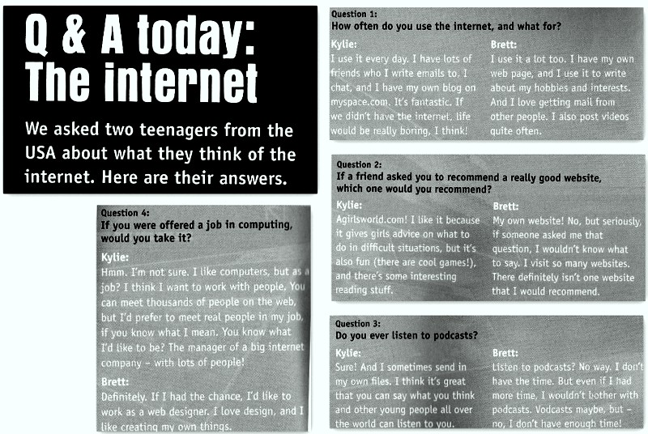

Actividades

- Con que frecuencia usas la computadora? Para que la usas? Para que la usan tus amigos o familiares?
- De donde crees que este texto fue extraido, Marca con una X y fundamenta tu respuesta:

      - Un periódico
      - Un libro de texto especializado
      - Una revista

- Lee rápidamente el texto y encuentra quién:
- Has their own web page.
- Listen to Podcasts.
- Would like to work in computing.

- Lee nuevamente el texto y diga si las siguientes oraciones son verdaderas o falsas e indica número de línea:

- Kylie has a blog.
- Brett has never posted a video
- Kylie doesn’t like the reading stuff on agirlsworld.com
- The interviewer asked Brett to recommend a website but he didn’t answer.
- Brett would like to have more time to listen to podcasts.
- Kylie isn’t sure if she would want to work in computing.

- Las ideas de quien compartís, Brett or Kylie?

- Lee las siguientes oraciones del texto. Son situaciones reales o imaginarias?

- If we didn’t have the internet, life would be really boring.
- Is someone asked me that question, I wouldn’t know what to say.

- ¿Qué tipo de oraciones condicionales son las dadas en el punto anterior. Encuentra más ejemplos en el texto y luego completa la siguiente regla:

REGLA: If +………. Simple, + ………./ would or would not + verb

- Traduzca un texto.

